1.
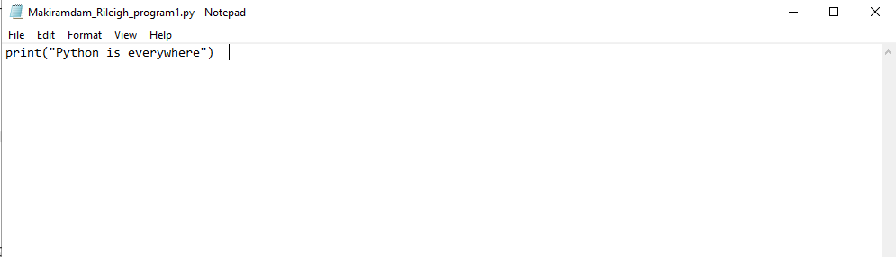

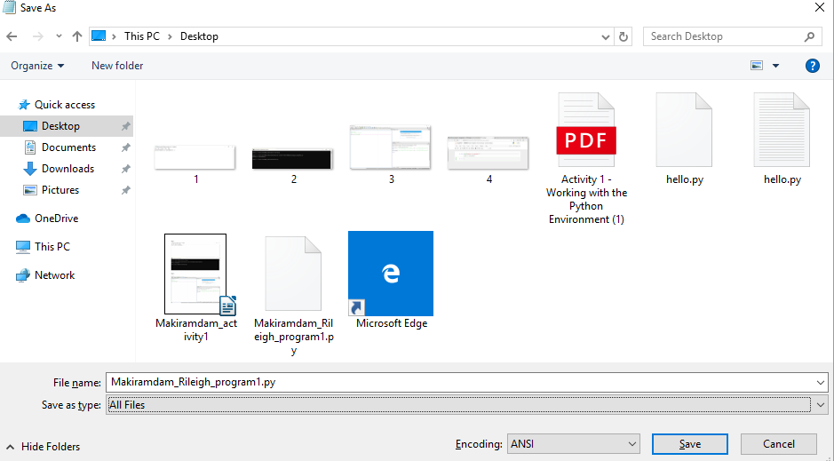

I type the print(“python is everywhere”) and save it as Makiramdam_Rieligh_program1.py and I save it in All documents

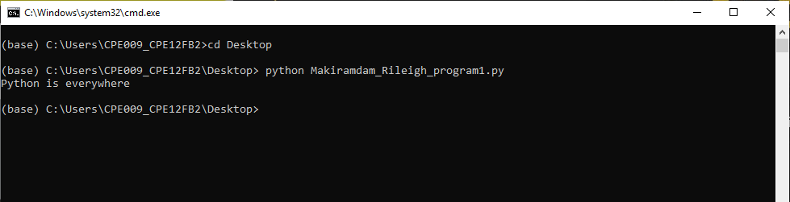
I check it on Anaconda navigator then in environment I click the base root then open terminal. I type first the cd Desktop becaude I save my notepad on my desktop then I type python Makiramdam_Rileigh_program1.py then I will show what I type inside the notepad

2.

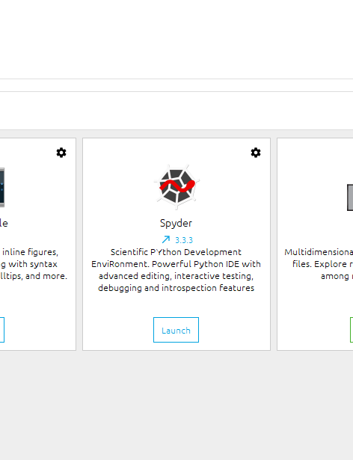
I open the anaconda navigator then I launch the spyder

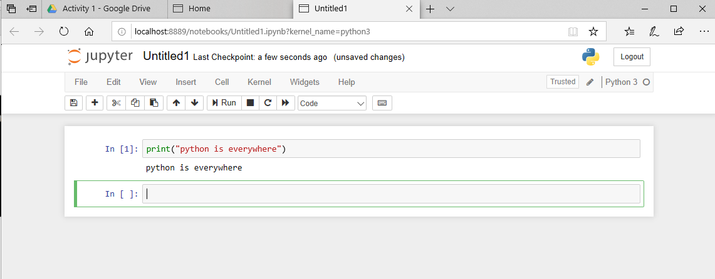

I print python is everywhere in Spyder and run where it display in the right side of the spyder app

3.
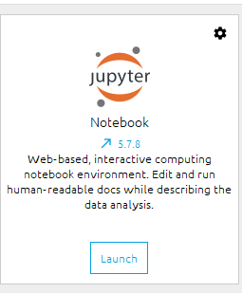

I open the anaconda navigator then I launch the jupyter

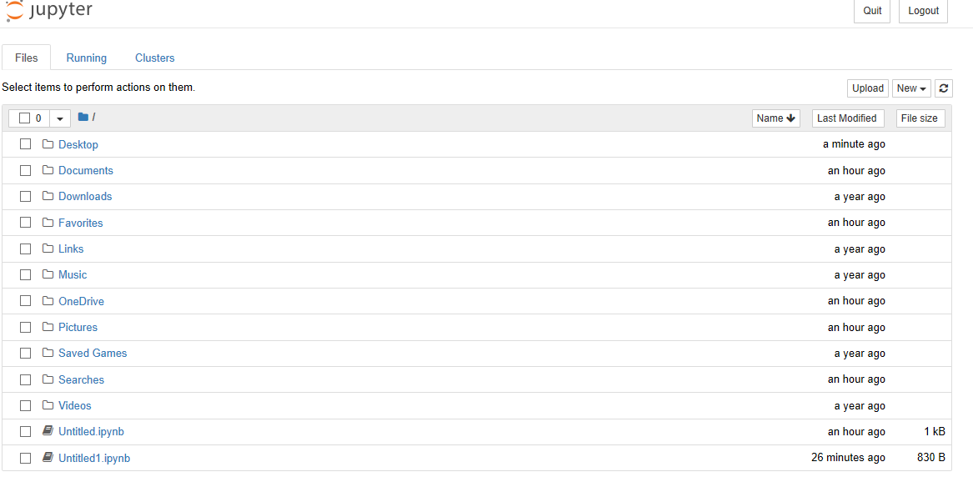

I click the new in the right side then click python 3

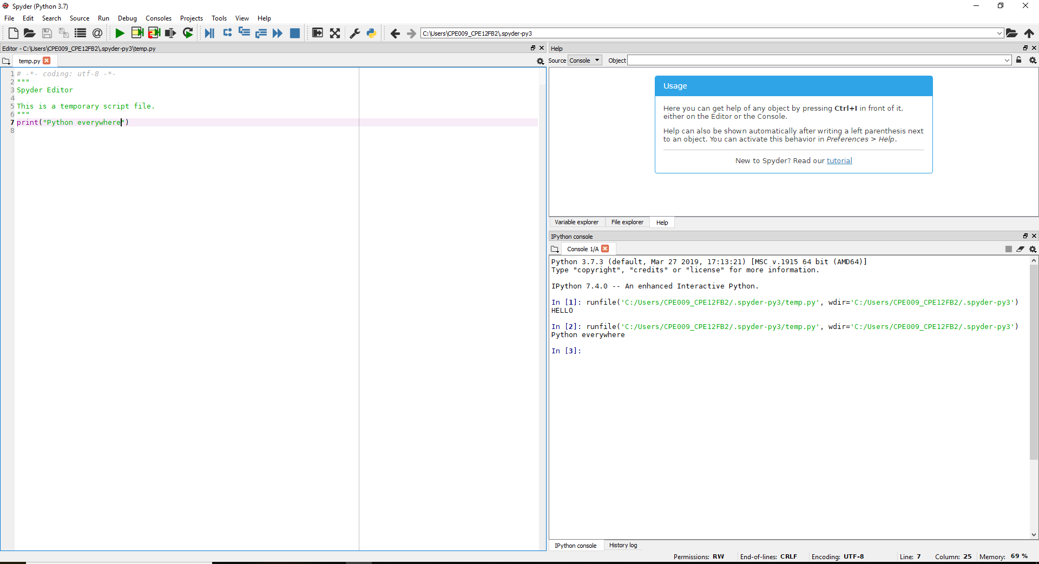

Then I choose the code and I type python is everywhere and it run below the print(“python is everywhere”)

1. How does Python differ with the previous programming language you have used in terms of syntax and execution?

In python the return type and data type like int is not needed. Also in putting a semi colon after a code, in python it is not needed to do. The printf in C will be only print in python. In execution if there is an error in python the compiler will show what is the exact error.

2. In the Open with Terminal option in Anaconda, what happens when you type the command python? Based from the discussion, what do you think is the advantage of this feature?

It will show syntax error. The advantage is if we want to see what is the output of the other program that we do we can easily see it just type first where did you save it and second is type python thename of the file .py

3. In the same window in number 2, type the command printf(“That’s not Python”). What is the output? Did the command prompt stop working after the output?

It will show
>>> printf("thats not pyton")
Traceback (most recent call last):
File "<stdin>", line 1, in <module>
NameError: name 'printf' is not defined
it did not stop.

4. What happens if you type python file1.py without creating such a file? Why do you think that was the output?

It will show python: can’t open file ‘file1.py’: [Errno 2] No such file or directory.

5. In the Jupyter Notebook, after the first code has been run a new block or cell has been created try putting the code print(“Your second block of code!”) and then run the notebook. What do you think is the difference between the Jupyter Notebook and Spyder IDE in terms of making Python programs?

The differnce is in the spyder it has a run file the it will show the output while in Jupyter is directly show the output.

Conlusion:

I learn how to install the anaconda navigator in my laptop. I also learn how to use the Jupyter notebook and spyder IDE. I learn how to use command prompt terminal in anaconda navigator and I also learn how to use python and how to type codes in python. For me using python ofr programming is much easier that C in dev C++. For me python is a short cut of C.

